# Assignment -1

|  |  |
| --- | --- |
| Assignment Date | 19 September 2022 |
| Student Name | S.AHATHIAN |
| Student Roll Number | 82031925004 |
| Maximum Marks | 2 Marks |

**Question-1:**

Create form of type input text, email, password, radio button, text area, drop down and navigate to successor page and display files of form in table (CSS, HTML)

|  |
| --- |
| **Solution:** |
| <html>  <head>  <title>Form</title>  <script type="text/javascript"> function displayDetails()  {  var name = document.getElementById("name").value; var email = document.getElementById("email").value; var gender = document.getElementById("gender").value; var year = document.getElementById("year").value;  var pl = document.getElementById("pl").value; document.writeln("<html><body>"); document.writeln("<table border='1'><tr>");  document.writeln("<th>Name</th><th>Email</th><th>Gender</th><th>Program mingLanguage</th><th>Year</th>");  document.writeln("</tr>");  document.writeln("<tr><td>"+name+"</td><td>"+email+"</td><td>"+gender+"</t d><td>"+pl+"</td><td>"+year+"</td>");  document.writeln("</tr></table>"); document.writeln("</body></html>");  }  </script>  </head>  <body>  <form method="post" onsubmit="displayDetails()">  <label for="name">Name:</label>  <input type="text" id="name" name="name" placeholder="Enter name"/><br/><br/>  <label for="email">Email:</label>  <input type="email" id="email" name="email" placeholder="Enter  email"/><br/><br/> |

<label for="pwd">Password:</label>

<input type="password" id="pwd" name="pwd" placeholder="Enter password"/><br/><br/>

<label for="address">Address:</label>

<textarea id="address" name="address" rows="4" cols="50"></textarea><br/><br/>

<label for="gender">Gender: </label>

<input type="radio" id="gender" name="gender" value="male">Male</input>

<input type="radio" id="gender" name="gender" value="female">Female</input><br/><br/>

<label for="pl">Programming languages: </label>

<input type="checkbox" id="pl" name="pl" value="java">Java</input>

<input type="checkbox" id="pl" name="pl" value="c">C</input>

<input type="checkbox" id="pl" name="pl" value="python">Python</input>

<input type="checkbox" id="pl" name="pl" value="c++">C++</input><br/><br/>

<label for="year">Year:</label>

<select name="year" id="year">

<option value="first">I</option>

<option value="first">II</option>

<option value="first">III</option>

<option value="first">IV</option>

</select><br/><br/>

<label for="submit">Submit:</label>

<input type="submit" value="submit"/><br/><br/></form></body>

</html>

# OUTPUT:

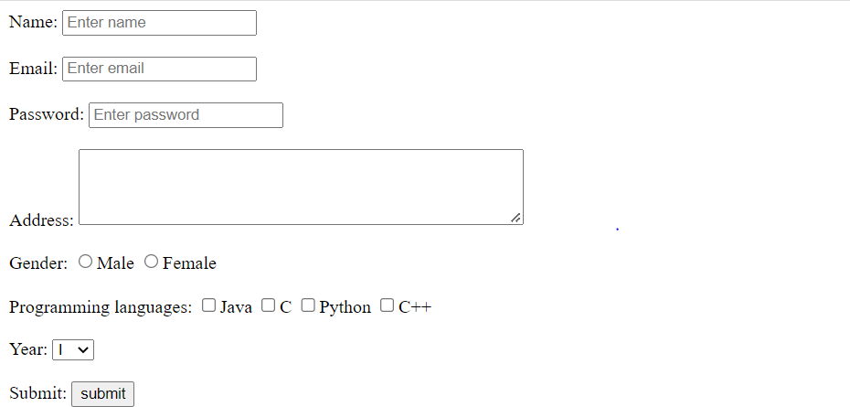

**Question-2:**

For the CSS create external style sheet for above task (separate css file and link that in html)

|  |
| --- |
| **Solution:** |
| <html>  <head>  <title>Form</title>  <script type="text/javascript"> function displayDetails()  {  var name = document.getElementById("name").value; var email = document.getElementById("email").value; var gender = document.getElementById("gender").value; var year = document.getElementById("year").value;  var pl = document.getElementById("pl").value; document.writeln("<html><body>"); document.writeln("<table border='1'><tr>");  document.writeln("<th>Name</th><th>Email</th><th>Gender</th><th>ProgrammingL anguage</th><th>Year</th>");  document.writeln("</tr>"); document.writeln("<tr><td>"+name+"</td><td>"+email+"</td><td>"+gender+"</td><t d>"+pl+"</td><td>"+year+"</td>");  document.writeln("</tr></table>"); document.writeln("</body></html>"); }  </script>  <link rel="stylesheet" href="style.css" type="text/css" /></head>  <body>  <form method="post" onsubmit="displayDetails()">  <label for="name">Name:</label>  <input type="text" id="name" name="name" placeholder="Enter name"/><br/><br/>  <label for="email">Email:</label>  <input type="email" id="email" name="email" placeholder="Enter email"/><br/><br/>  <label for="pwd">Password:</label>  <input type="password" id="pwd" name="pwd" placeholder="Enter password"/><br/><br/>  <label for="address">Address:</label>  <textarea id="address" name="address" rows="4" cols="50"></textarea><br/><br/> |

<label for="gender">Gender: </label>

<input type="radio" id="gender" name="gender" value="male">Male</input>

<input type="radio" id="gender" name="gender" value="female">Female</input><br/><br/>

<label for="pl">Programming languages: </label>

<input type="checkbox" id="pl" name="pl" value="java">Java</input>

<input type="checkbox" id="pl" name="pl" value="c">C</input>

<input type="checkbox" id="pl" name="pl" value="python">Python</input>

<input type="checkbox" id="pl" name="pl" value="c++">C++</input><br/><br/>

<label for="year">Year:</label>

<select name="year" id="year">

<option value="first">I</option>

<option value="first">II</option>

<option value="first">III</option>

<option value="first">IV</option></select><br/><br/>

<label for="submit">Submit:</label>

<input type="submit" value="submit"/><br/><br/></form></body></html>

# style.css

body {

background-color:pink; border-style: solid;} table, th, td { border:1px solid;

}

# OUTPUT:

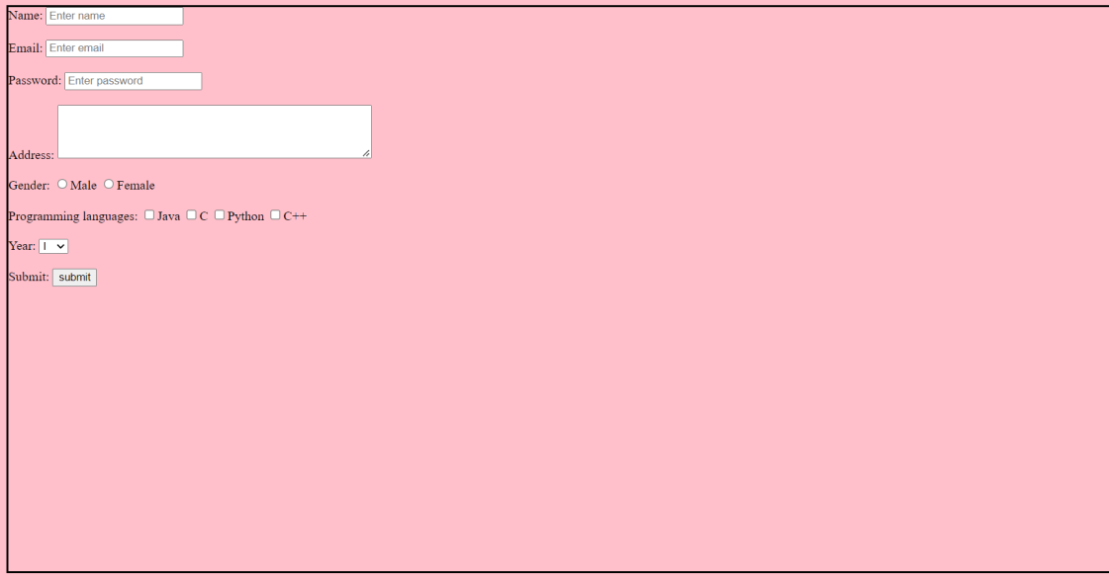

|  |
| --- |
| **Question-3:** |
| Create sample program for Flask HTTP methods (list or map and perform operations of PUT, GET, DELETE and POST) |
| **Solution:** |
| from flask import Flask,request,json app=Flask( name )  cars={"1":"Lamborghini", "2":"Ferrari" , "3":"Porsche" , "4":"Landrover" , "5":"Bugatti", "6":"Mercedes" ,"7":"Rolls-Royce" , "8":"BMW"}  @app.route('/data' ,methods=['GET','POST']) def api():  if request.method=='GET': return cars  if request.method=='POST': data=request.json cars.update(data)  return 'data got inserted' @app.route("/data/<id>",methods=['PUT']) def update(id):  data=request.form['items'] cars[str(id)]=data  return 'data updated' @app.route("/data/<id>",methods=["DELETE"]) def deleteoperation(id):  cars.pop(str(id)) return 'data deleted'  if name ==' main ': app.run(debug=True)  **Output:** |